Print bed assembly

Vitamins
1 PCB bed mk42  4 M3 cap screw x 10mm  6 Hex male / female pillar M3 x 20mm | 2 Heatshrink sleeving ID 1.6mm x 15mm  2 Heatshrink sleeving ID 2.4mm x 15mm  2 Heatshrink sleeving ID 6.4mm x 30mm  4 Washer M3 x 7mm x 0.5mm  1 Black wire 32/0.2 length 635mm  1 Red wire 32/0.2 length 620mm

Sub-assemblies
1 y_carriage_assembly
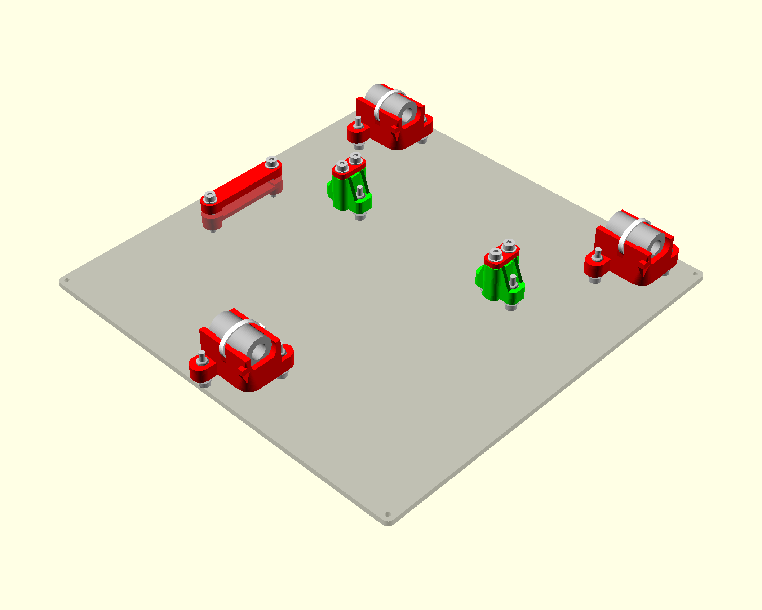

Bed Wiring

- Solder the red wire to the positive terminal and the black to negative.
- Place a strip of kapton tape where the thermistor wires will go.
- Use kapton tape to tape down the thermistor. Place the thermistor at the center hole. Don’t force it in but just let it rest there.
- Use red and black wires trimmed from the X motor for the thermistor wiring extension.
- Insert the hex screws at each corner and the 2 near the center
- mount the heat bed with 6 countersink screws
- attach the wires to the zip ties to the holes going from the corner towards the center.
- Fold the wires over the edge near the center and attach to carraige with the holes going from the edge at the center towards the center

Assembly
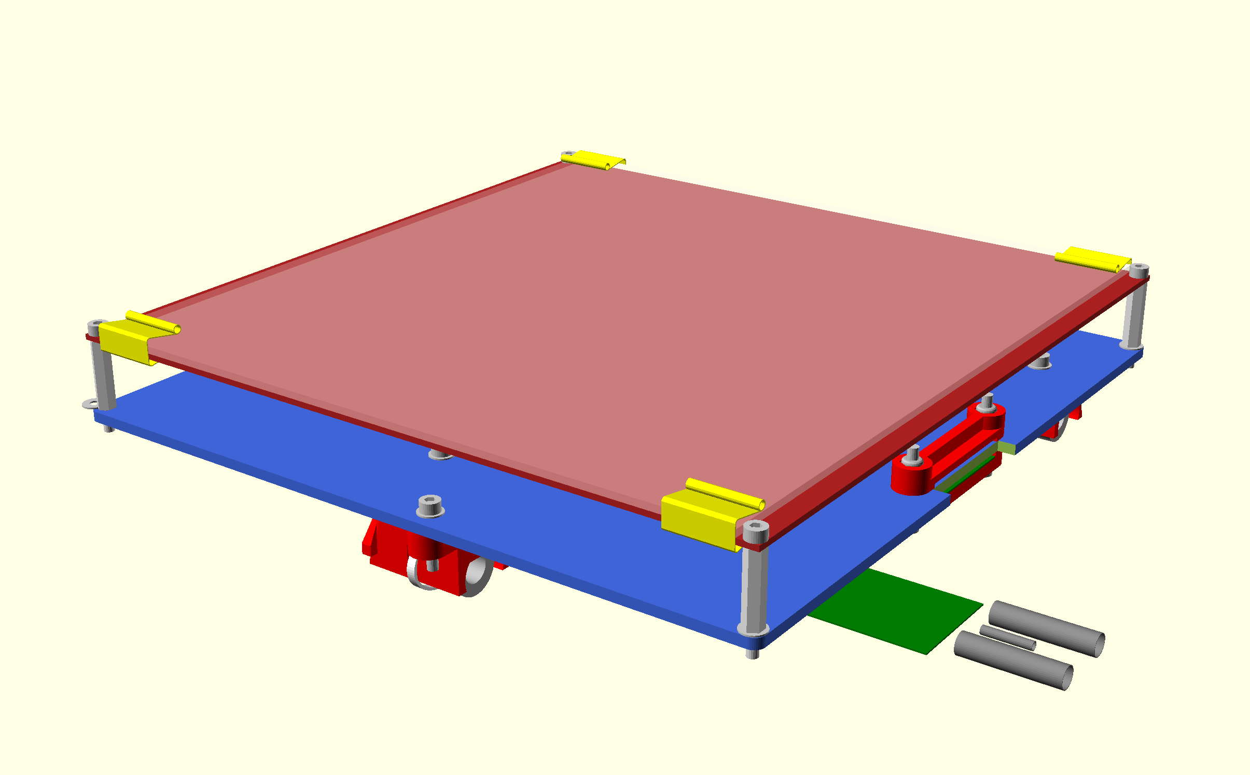
- Tap the corner holes and the 2 center holes to 3mm. Screw the pillars into the Y carriage, but don't over tighten as it is quite soft. Note that the rear two pillars have a washer under them. The front two are initially spaced the same distance by using a washer as a temporary shim. They can then be adjusted up or down slightly to level the bed relative to the nozzle.
- The bed is installed with the cable at the back. It initially leads off forwards and then loops back on itself under the top ribbon clamp. It then doubles back under the Y carriage through the lower cable clip.
- Screw the bed to the top of the pillars with the M3 x 10 cap screws (no washers). Just start the screws as you will need to take the bed off again to tighten the last bearing holder. This is best done when belt etc. are in place

TO BE DONE: DP notes says to use button head screws as they reduce height and interference with HE and then no PP strip used?

- Pull the ribbon cable tight enough so that the loop under the bed does not touch the bed and clamp it together with the polypropylene strip (which goes closest to the clamp).

